**[SPE1053L]**

**NEWCASTLE UNIVERSITY**

**_________________**

**SEMESTER 2 2018/19**

**_________________**

**LINGUISTICS AND PHONETICS I:**

**LINGUISTICS**

**Time allowed: One hour (60 minutes)**

**Instructions to candidates:**

1. Answer **ALL** **SIX** questions, which are equally weighted.
2. There are pages for rough work at the end of this exam paper. These **must** be handed in.

**Student Identification Number:** (no names please, so that texts can be blind marked)

**___________________ MARK: _______%**

**(1) Word classes and functions**

For these sentences

(a) label all of the syntactic functions

(b) label all of the functions and word classes

EXAMPLE

The big grey mare nuzzled the tottering foal

FUNCTIONS: | **S** | **V** | **Od** |

WORD CLASSES: **D Adj Adj N v D Adj N**

NB all words must belong to a syntactic function. You could use vertical lines as above, or a horizontal line, e.g.

The big grey mare

--------------S----------------

A list of functions and word classes are provided at the end of this booklet (please feel to detach the pages)

a) Geoff was punished by his parents last night

b) The teacher awarded him an extra star for his fantastic essay

c) For Pete’s sake stop playing that music so loud !

d) The poor depressed servant cried herself to sleep

**(2) Dependent (subordinate) clauses.**

(i) For each sentence, draw a line under the dependent clause(s).

(ii) For each dependent clause, write a brief description of the role/function of that dependent clause. For clauses which are complements (**Od, Oi, Cs, Co**), which word are they the complement of? For modifying clauses (**A and PMod**), what do they modify?

(iii) Put a box around subordinating words, and a circle around coordinating words.

Examples

Jack was surprised when he heard the news

Adverbial Clause modifying main clause (“jack was surprised”)

It was angry that he lost my wallet

Clause is complement of adjective “angry”

(a) Jack is always on for a party as long as there is copious booze

(b) I was really surprised that he didn’t turn up for the exam

(c) I prefer the house that has the stained glass windows

(d) Whilst eating a hummus sandwich he suddenly realised his crown had fallen out

(e) Because the fish he bought smelt slightly off he took it back to the fishmonger’s.

(f) Angelito proposed that until Jorge moved out they should share the household chores

**(3) Labelling tense, aspect and voice**

For each of the following sentences, label the tense, grammatical aspect and voice.

*Possible tenses*: Present, past, “future”, NONE

*Possible grammatical aspects*: Progressive, Perfective, Progressive Perfective, NONE.

*Possible voices*: Active, passive.

|  |  |
| --- | --- |
| (1) They won’t have finished interviewing yet | Tense:  Aspect:  Voice: |
| (2) So much had been written about that terrible event | Tense:  Aspect:  Voice: |
| (3) The roof of the house was being repaired | Tense:  Aspect:  Voice: |
| (4) Stop being so silly! | Tense:  Aspect:  Voice: |
| (5) You’ll be laughing all the way to the bank | Tense:  Aspect:  Voice: |
| (6) She’d been studying Latin for over five years | Tense:  Aspect:  Voice: |
| (7) What’s your opinion about the incident? | Tense:  Aspect:  Voice: |
| (8) Dinner is served. | Tense:  Aspect:  Voice: |

**(4) Psycholinguistic data / models**

In the exam there will be a choice between two questions. This practice exam only contains one (so I don’t run out of good questions to ask!). There are three lectures this semester focused on psycholinguistic topics: the two lectures on language processing (comprehension) in Weeks 8 and 9, and the lecture on Linguistics in the clinic (week 10). The week 9 lecture on formulaic language also discusses a psycholinguistic model of the relationship between formulaic and productive processes.

INSTRUCTIONS: Choose **one** of the following two questions. Write an answer of about 100 words (half a page)

(a) What do we mean by the “parser”? To what extent does it work in a bottom-up fashion?

(b) _ _ _ _ _ _ _ _ _ _ _ _ _ _ _ __ _ _ _ _ _ _ __ _ _ _ _ _ _ __ _ _ _ _ _ _ __ _ _ _ _ _ _ _

*Page for writing answer*

**(5) Clinical materials / data**

Look at the following picture prompts which belong to standardised assessments. Write an ideal response (ie what sentence does the child need to produce, or what picture do they need to point to). Then describe the “linguistic ability” that is being assessed?

When describing the “linguistic ability” try to use linguistic terminology which has been introduced in the lectures, and refer to specific word classes or constructions you have come across, e.g. “the ability to use prepositions”, “the ability to use the Verb Phrase”, or “the ability to use the superlative construction”.

Answers should be between one and three sentences long depending on what abilities are being measured

NB there are two items for you to practice. The actual exam will have **four**.

*1. Mummy wants to know if the boy has brushed his teeth, so what does she say?*

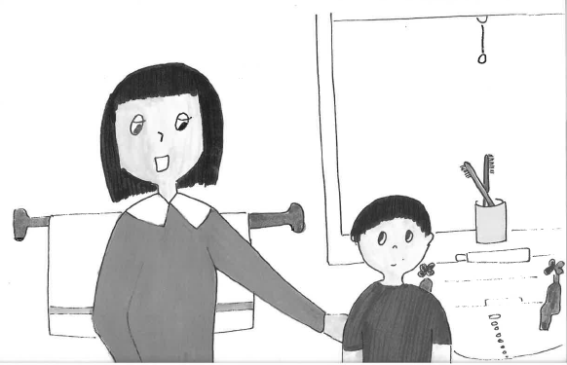

TARGET RESPONSE:

WHAT LINGUISTIC ABILITIES ARE BEING ASSESSED?

*2. The girl is being pushed by the boy*

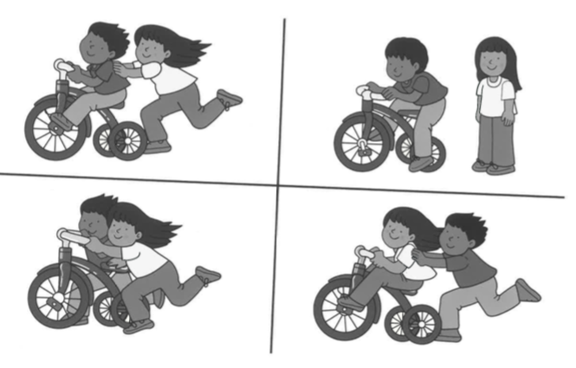

TARGET RESPONSE:

WHAT LINGUISTIC ABILITIES ARE BEING ASSESSED?

**(6) Mini essay**

Write about 50 - 150 words (half a side to a side) on **one** of the following topics. If you run out of time you can make notes. High marks will be given if your notes contain relevant content.

The topics will all be from semester 2

In order not to run out of good essay titles, I have included only one in this practice exam.

(a) What do we mean by “mood” and how is it manifested in terms of sentence structure?

*Page for writing answer*

*Page for writing answer*

*Page for writing answer*

*Page for writing answer*

*Page for writing answer*

*Page for writing answer*

*Page for writing answer (THIS IS THE FINAL PAGE)*

**LABELS**

(Please detach this sheet if you wish, but hand in at the end of the exam)

Labels for syntactic functions:

S: Subject

Od: Direct Object

Oi: Indirect Object

Cs: Subject Complement

Co: Object Complement

A: Adverbial

Labels for word classes

Open class:

N: Noun

v: Main or lexical verb

Inf: Used to mark an infinitive verb, e.g. *to go*.

Adj: Adjective

Comp: Comparative Adjective or Adverb

Int: Intensifier, e.g. *very* good.

Closed-class

D: Determiner

Pr: Preposition

Pron: Pronoun

Aux: auxiliary verb, e.g. *have done.*

Cop: Copula (verb *to be* used as the main verb)

Neg: Negative particle

Part: Verb particle, e.g. put *down*.

gen: Anglo-saxon genitive ‘s

Dummy elements

It: Dummy *it,* e.g. ***it****’s raining*

There: Dummy *there*, e.g. ***there****’s a party on Tuesday*

Combining clauses

c: Coordinator (*and, but*)

s: Subordinator (e.g. *although, because*)